**BigData Hadoop: Assignment 1.1**

Open the Oracle VM VirtualBox Manager and click Import Appliance

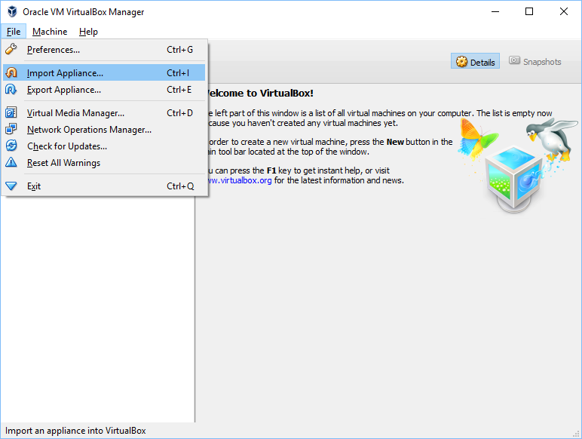

Import downloaded acadgild .ova file

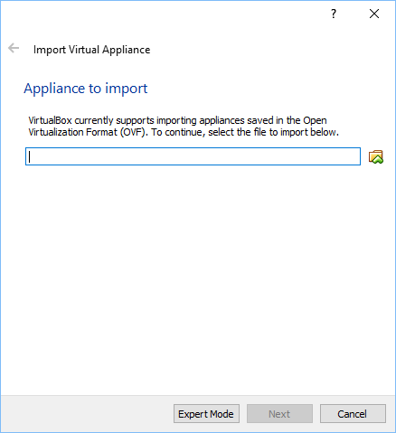

Click Import

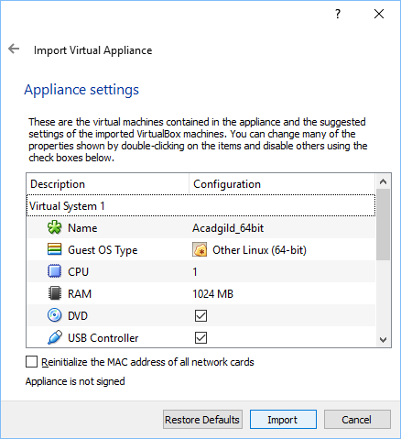

Import starts!

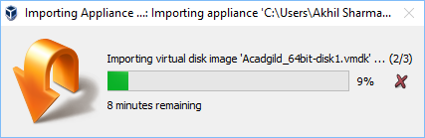

**Acadgild_64bit installed!**

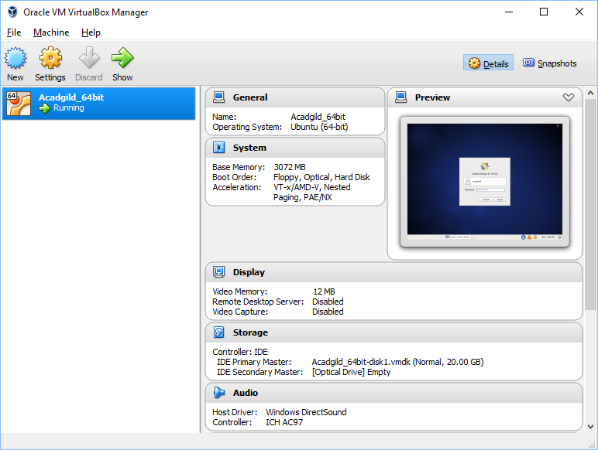

**Snapshot of OS!**

